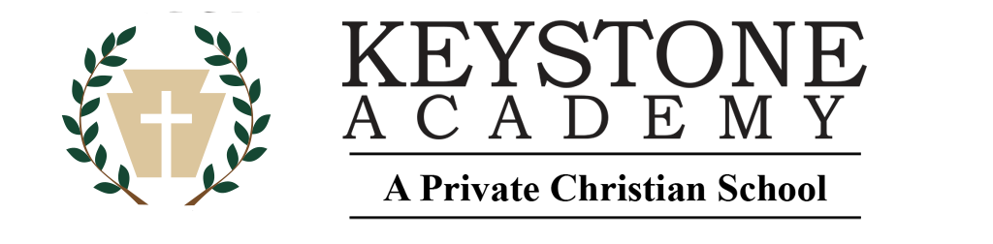
Teacher’s Memo: Sign in at the Third Quarter’s Teacher Training Session
Bring Parent Teacher Guide and Supplements in 3-ring Binder
Turn in:

Student Portfolio: Attach samples of student work in Bible, English, Math, Science,
Social Science (History/Geography), Health, and Fine Arts.
One page, copy or photo of project is sufficient; this will be returned.

Attendance Chart: Bring this filled in; it will be signed and returned.

Week # 19—27 (Optional) Lesson Log pages if feedback is desired.

Keystone Parent Association business: donations, fundraisers, etc.

Yearbook photos: Please submit yearbook photos for this quarter to the link you were emailed for
each field trip, picnic, beta club event, activity, etc.

Offering envelope for FPM

Offering envelope for NHERI

“Suggested donation” $9 for each, accumulate $1 per week throughout the quarter
An Attitude of Gratitude
The staff who work here in Keystone are blessed by your gratitude and encouraging comments. Take a moment to jot notes to those who have blessed you this year. Let them know how your educational experience is better because of their labor. Bring them to the 3rd quarter meeting and deliver into their “mail” bags at the beginning of the meeting.

Elementary K - 6th
Student Portfolio
Academic Year 2024/25 Dates:____________________

“Be ready always to give an answer to every man that asks you, yet with meekness and fear:
Having a good conscience that, wherein ye are spoken against,
they may be put to shame who revile your good manner of life in Christ.” I Peter 3: 15, 16

Student Name___________________________Grade___________
Third Quarter Weeks Present __________ Total Days Absent_________
Year-to-Date Weeks Present #19 - 27 (usually 27) _______

Extra Curricular Year to date accumulated totals
Jr. Beta Club accumulated hours

Teacher Name ____________________________________ Comments:

Reviewed by_________________________ Date________________

